ELEMENT 3: ACTIVITY 2: LO4

Building awareness

PART ONE

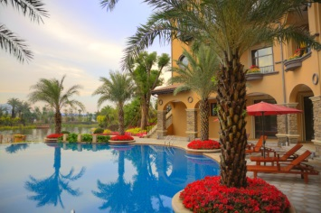The Palm Court Hotel is a 150 bedroom hotel in a coastal resort with a restaurant, bar and function room that can cater for up to 200 guests. The bedrooms are occupied from April through to October with an average 60% occupancy and the function room hosts 15 functions per year.

The new owner, who bought the hotel six months ago, is particularly concerned some negative comments about the rooms that have been left on a leading international hotel review site, the limited trading period each year, and the lack of use of the function room.

He is keen to build awareness of the business to generate all year round occupancy and has asked for your help in developing some creative content using digital and online tools.

What digital and online tools might The Palm Court Hotel’s target audience use? List your ideas below.

Write a creative content idea for each relevant tool that will raise awareness of his business, e.g. a digital PR story, a blog post or social media campaign.

