ELEMENT 4: ACTIVITY 1: LO7
Identifying the customer proposition

PART ONE

Read the following case study.
Case study: EduLife – Closing the Gaps and Opening the Future

“I see a lot of gaps in education provision in Tanzania, especially the question of ‘ACCESS’ to books, trained teachers and good environment.” Theresia of EduLife

Theresa, aged 31 years, founded EduLife to reduce the struggle that children often have in rural schools. In Tanzania, 90% of children in rural public schools struggle to learn because they do not have qualified teachers or books or an environment conducive to learning.

Opening the Future in Tanzania and Beyond

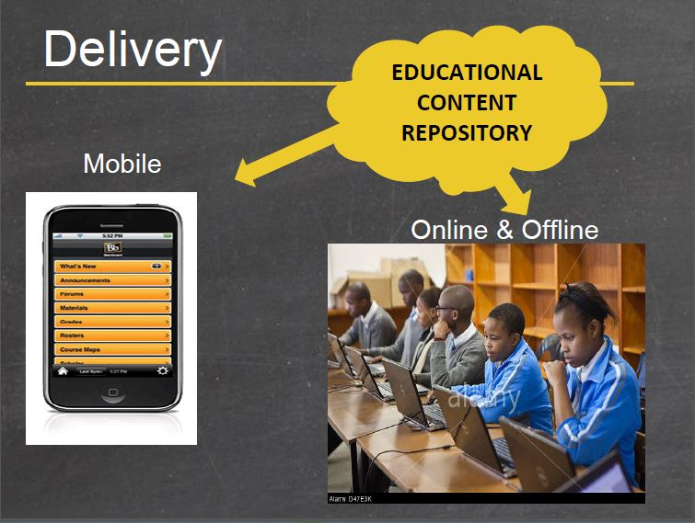
Theresia’s digital education aims to give rural Tanzanian children an education like their counterparts around the world. Today, good relevant books are scarce. But tomorrow, with EduLife, children can download relevant educational literature and resources. Educational materials are accessible online on laptops, as mobile apps, and also offline on desktop computers.

“Our content is focused on nine Secondary School subjects that are based on the National syllabus, includes all the compulsory subjects that they have to sit for at the National exams and two optional subjects of Science. Content will be digitized and stored on an open source, using learning podcasts that can be delivered using mobile IVR or radio.”

A Fundamental Right and a Bright Future

EduLife is accessible via local mobile platforms for children. Affordable pricing removes the financial barriers for many students and their families. Theresa’s business closes the gap in Tanzania for its children and opens that generation to a promising future.

Source: https://africanentrepreneurshipaward.com/close-the-gaps-and-open-a-generations-future/

Define the characteristics of EduLife’s key customer segments.

Target segments

PART TWO

Referring to the EduLife case study and target segments identified in Part One, write a customer proposition for one segment that describes why a customer might buy its products that could be used on the home page of its website.

