4UIQM: Element 2: Algebraic methods
Solutions to activities

Activity 1 | - 70x +25  - x = variable, 25 = constant and 70 = coefficient
Activity 2 | - $5a^{5}b^{2}c$ and $2b^{2}a^{5}c$  - $3x^{3}y$ and $3yx^{3}$  $5xy$ and $3xy$
Activity 3 | - 6  - $72x^{2}y^{3}z^{2}$  - $45t^{7}$  - $4u^{5}\left(u+4\right)$  - $\frac{1}{\sqrt{x}}+xy^{4}z$
Activity 4 | $$1+2x^{2}y-3z^{3}=36xyz-xy-\frac{5x}{y}-5y$$
Activity 5 | - u = -4  - x = -5  - t = $5\frac{2}{3}$
Activity 6 | u= 13, v = -11
Activity 7 | - x = 3, y = 7  - x = 5, y = 2  - x = 6, y = 3  - x = 4, y = -2
Activity 8 | x = 24, y = 12
Activity 9 | Adult’s meal $18  Child’s meal $10
Activity 10 | - $x=-\frac{1}{2}$ and 3  - t = 1 and $1\frac{1}{4}$  - x = -2 and -4  - y = -1 and $\frac{2}{3}$
Activity 11 | 7.74 feet
Activity 12 | - x = 3.19 and -2.19  - x = 1.15 and -0.65  - x = 0.28 and -1.61  - x = 2.41 and -0.41
Activity 13 | 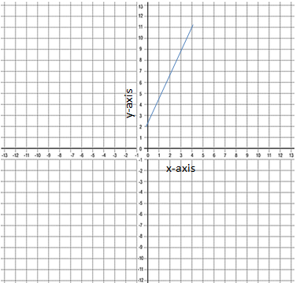  - Straight line
Activity 14 | - Gradient = $-\frac{1}{3}$ , y-intercept = $-\frac{2}{3}$  - Gradient = -2 , y-intercept = 4  - Gradient = $-\frac{5}{3}$ , y-intercept = 3  - Gradient = $\frac{1}{2}$ , y-intercept = -2
Activity 15 | - $y=\frac{1}{6}x-5$  - $y=0.7x+1$
Activity 16 | - y = -3x + 9, y-intercept = 9  - y = -2x + 4, y-intercept = 4  - y = - x – 2, y-intercept = -2  - y = $\frac{1}{2}x+2$ , y-intercept = 2

