4UIQM: Element 3: Business Statistics
Solutions to activities

Activity 1 | Examples of data include: call duration, number of local/outstation calls, amount per call, numbers called  Examples of information gained could include: average amount spent per day, average calls per day, ratio of outstation to local calls, average duration
Activity 2 | Primary  Secondary  Primary  Secondary
Activity 3 | Qualitative  Quantitative
Activity 4 | Discrete
Activity 5 | Continuous  Discrete  Continuous  Continuous  Discrete
Activity 6 | Questions could gather data on gender, age, frequency of purchase, number of units purchased. However, this is not an exhaustive list.
Activity 7 | Total population  Male/female  Education level  Age groups  Ethnic groups
Activity 8 | Stratified  Cluster
Activity 9 | Nominal
Activity 10 | Gender Play games Total  Only on mobile phone Only on gaming console  Male 13 7 20  Female 15 5 20  Total 28 12 40
Activity 11 | 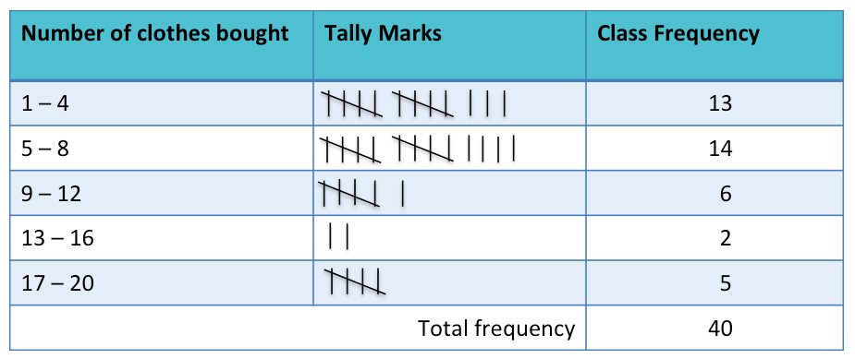
Activity 12 | Number of games bought Class frequency Relative frequency (%) Cumulative frequency  1-4 13 33 13  5-8 14 35 27  9-12 6 15 33  13-16 2 5 35  17-20 5 12 40  Total 40 100

