4UIQM: Element 4: Statistical tools and data analysis
Solutions to activities

Activity 1 | Interpretation: The highest sales are in July each year and lowest in December. This clearly shows the seasonality of sales. With passing years sales are showing a rising trend.
Activity 2
Activity 3 | Interpretation: Chocolate flavour has the maximum sales followed by butterscotch. Together these account for 50% of the total sales. The lowest sales are for raspberry flavour.
Activity 4 | 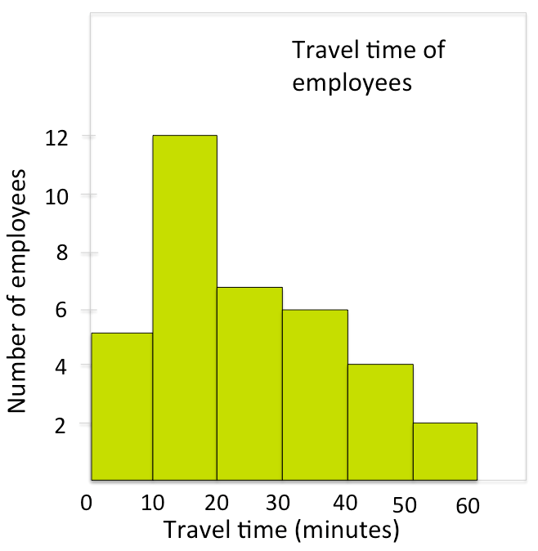
Activity 5 | 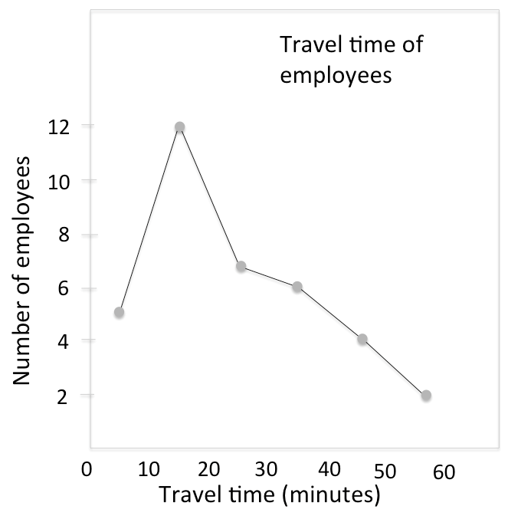
Activity 6 | 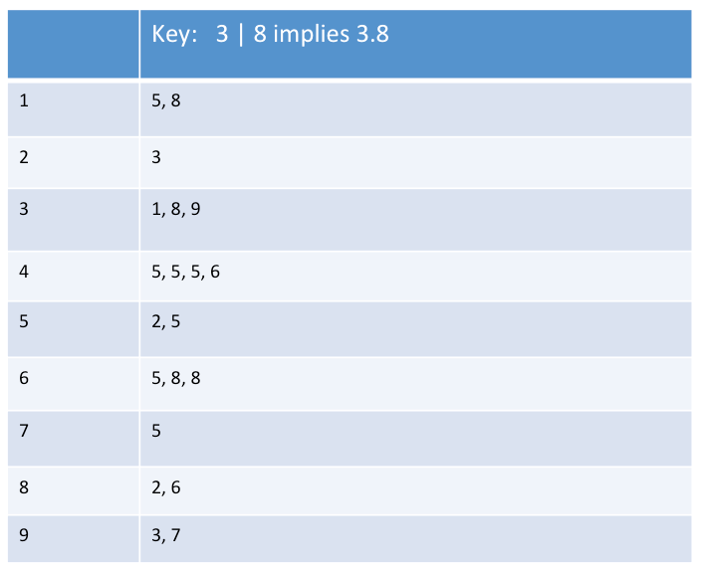  Interpretation: The duration of most of Theiry’s mobile calls is between 4-5 minutes. The most frequent duration of her call is 4.5 minutes. The range of duration of her calls is between 1.5 minutes to 9.7 minutes.
Activity 7 | Mean: 24.44  Median: 21.42  Mode: 15.83
Activity 8 | Standard deviation = 14.33

