**PROJECT MANAGEMENT**

**Element 2**

**Solutions to activities**

**Activity 1 solution**

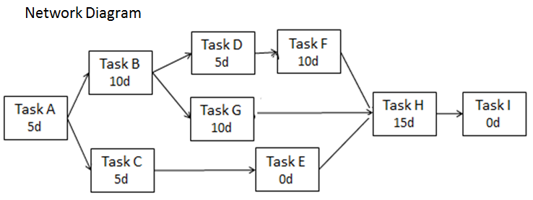

Critical path and planned duration of the project:

|  |
| --- |
|  |

**Activity 2 solution**

Gantt chart:

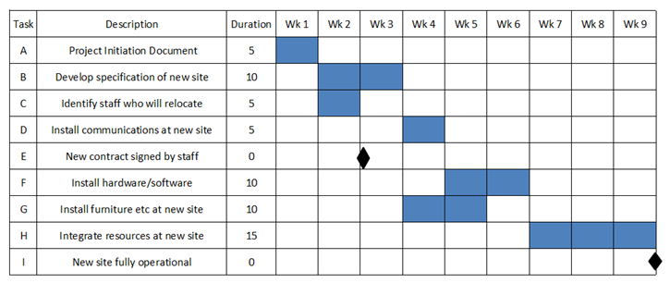

*Note that the black diamonds represent milestones (zero duration)*

**Activity 3 solution**

If the project starts on 5 April and proceeds according to the 9 week plan, then it should complete on Friday 4 June. Therefore the following Thursday will be 10 June.

Task C delay:

|  |
| --- |
|  |

**Activity 4 solution**

1. Simple network diagram:

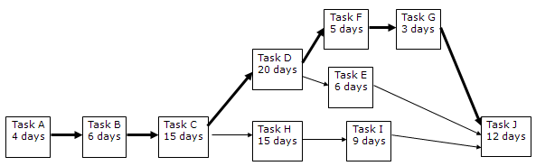

(b) The critical path runs through tasks A – B – C - D – F – G – J.

The durations of the critical tasks total 65 days (13 weeks) which is the planned duration of the project

(c) A general rule in these circumstances is to prioritise potential savings on critical tasks (which determine the length of the project).

|  |  |
| --- | --- |
| **Option** | **Accept?** |
| 1. By working longer days, 3 days could be saved on the Foundations (Task B). | YES – SAVE THREE DAYS |
| 1. By using extra construction staff, up to 2 days could be saved on the Executive Boxes (Task F). | YES – SAVE TWO DAYS |
| 1. Simplifying the lighting in the Banqueting suite with plasterboard walls would save 5 days from Task H | NO – NOT ON CRITICAL PATH |
| 1. Simplifying the TV studio specification would reduce Task I by 4 days | NO – NOT ON CRITICAL PATH |
| 1. Hiring an additional painting contractor could save 5 days on completion work (Task J) | YES – SAVE FIVE DAYS |

By accepting options 1, 2 and 5 a total of 10 days (2 weeks) can be saved.