**PROJECT MANAGEMENT**

**Learning Outcome 3: ACTIVITY 1**

**PAIRS/GROUP ACTIVITY**

**Mobile phone project**

A leading telecoms manufacturer is considering a new mobile phone development, using the following high level project plan. The project has yet to start.

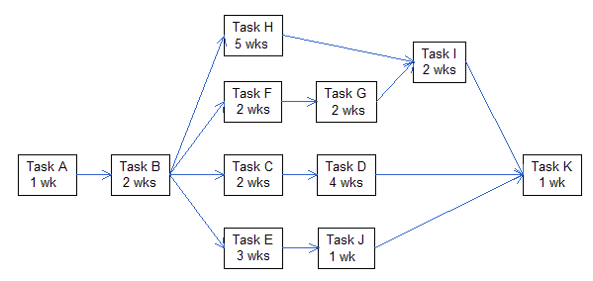

Further cost information ($) has been made available about each task.

|  |  |  |  |  |  |
| --- | --- | --- | --- | --- | --- |
| Task | Fixed costs | Variable costs/week | Task | Fixed costs | Variable costs/week |
| A | - | 3,000 | F | 35,000 | 2,000 |
| B | 12,000 | 4,000 | G | 20,000 | 1,200 |
| C | 25,000 | 4,000 | H | - | 2,500 |
| D | 20,000 | 5,000 | I | 15,000 | 3,000 |
| E | - | 6,500 | J | 9,000 |  |
|  |  |  | K | - | 2,400 |

In addition to the costs shown in the table, variable costs of £5,000 per week will be payable during the duration of the project.

**Questions**

(a) Based only on the network diagram supplied, find the critical path, the project duration and determine the planned start date if the project is to COMPLETE on Friday 25 November. A calendar is provided at the foot of this page.

(b) Calculate an overall budget for the project. Show all your workings.

|  |  |  |  |  |  |  |  |  |  |  |  |  |  |  |  |  |  |  |  |  |  |  |  |
| --- | --- | --- | --- | --- | --- | --- | --- | --- | --- | --- | --- | --- | --- | --- | --- | --- | --- | --- | --- | --- | --- | --- | --- |
| September | | | | | | |  | October | | | | | | |  | November | | | | | | |  |
| Su | Mo | Tu | We | Th | Fr | Sa |  | Su | Mo | Tu | We | Th | Fr | Sa |  | Su | Mo | Tu | We | Th | Fr | Sa |  |
|  |  |  |  | 1 | 2 | 3 |  |  |  |  |  |  |  | 1 |  |  |  | 1 | 2 | 3 | 4 | 5 |  |
| 4 | 5 | 6 | 7 | 8 | 9 | 10 |  | 2 | 3 | 4 | 5 | 6 | 7 | 8 |  | 6 | 7 | 8 | 9 | 10 | 11 | 12 |  |
| 11 | 12 | 13 | 14 | 15 | 16 | 17 |  | 9 | 10 | 11 | 12 | 13 | 14 | 15 |  | 13 | 14 | 15 | 16 | 17 | 18 | 19 |  |
| 18 | 19 | 20 | 21 | 22 | 23 | 24 |  | 16 | 17 | 18 | 19 | 20 | 21 | 22 |  | 20 | 21 | 22 | 23 | 24 | 25 | 26 |  |
| 25 | 26 | 27 | 28 | 29 | 30 |  |  | 23 | 24 | 25 | 26 | 27 | 28 | 29 |  | 27 | 28 | 29 | 30 |  |  |  |  |
|  |  |  |  |  |  |  |  | 30 | 31 |  |  |  |  |  |  |  |  |  |  |  |  |  |  |