**PROJECT MANAGEMENT**

**Learning Outcome 4: ACTIVITY 1**

**GROUP ACTIVITY**

**NGL plant: part one**

A multi-million dollar NGL plant has been planned for development in seven elements as shown in Figure 1. You are the project manager.

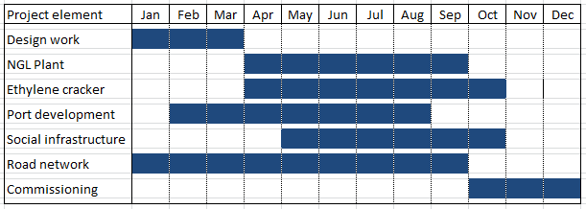

**Figure 1**

Today - 30 June, a senior executive team will arrive to review the entire project.

In preparation for a project review meeting with the executive team later today, you are required to analyse the Gantt chart in Figure 1 and calculate the **planned progress** at this point for each of the seven project elements shown in column 1.