**PROJECT MANAGEMENT**

**Learning Outcome 4: ACTIVITY 2**

**GROUP ACTIVITY**

**NGL plant: part two**

This activity builds on the analysis started in the last session.

To recap, a multi-million dollar NGL plant has been planned for development in seven phases is shown in Figure 1. You are the project manager.

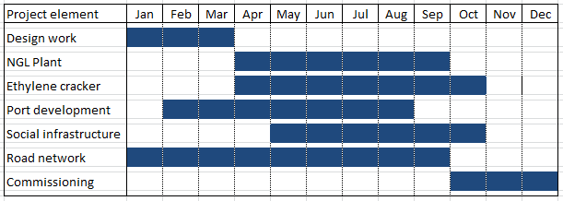

**Figure 1**

On 30 June, a senior executive team arrived to review the project.

In preparation for the meeting the following information was made available to them:

* Design work had all been completed on time.
* The main contractor has advised that the NGL plant now stands at 65% complete.
* The main structure of the Ethylene Cracker has finally been erected although there were delays due to very poor drainage of the site and difficult foundation works. The installation of the main fractionation system is now proceeding. The Ethylene Cracker is currently estimated as 20% complete.
* Dredging activity for the port development was delayed due to lack of available dredging vessels in the region. A suitable vessel has now been found and progress on the port stands at 60%.
* Social infrastructure is now 40% complete and the road network is 50% complete.
* Commissioning work is not planned to start for several months.

**QUESTIONS**

1. Compare the percentage progress (planned vs actual) of each phase after six months (on 30 June).
2. Prepare a management summary (bullet points) for the entire project, highlighting any concerns.