**ANALYTICAL DECISION-MAKING**

**Learning Outcome 2: ACTIVITY 1**

**Management information systems and structure**

*In pairs:*

Referring to the diagram on the next page, split up the tasks into four activities as shown - with feedback after each.

|  |  |
| --- | --- |
| 1 | Give examples of types of business transactions which could form part of the **intranet** and the **extranet** of an organisation |
| 2 | 1. Identify types of external information which would be useful to hold in the external database of a company 2. Why would you hold this information? |
| 3 | 1. For each functional area of the business, develop a list of databases and their uses which might form part of a departmental information system 2. What is their importance? |
| 4 | Based on task 3 and slide 11, give examples of output presentations for reporting on each of the databases identified in task 3. |

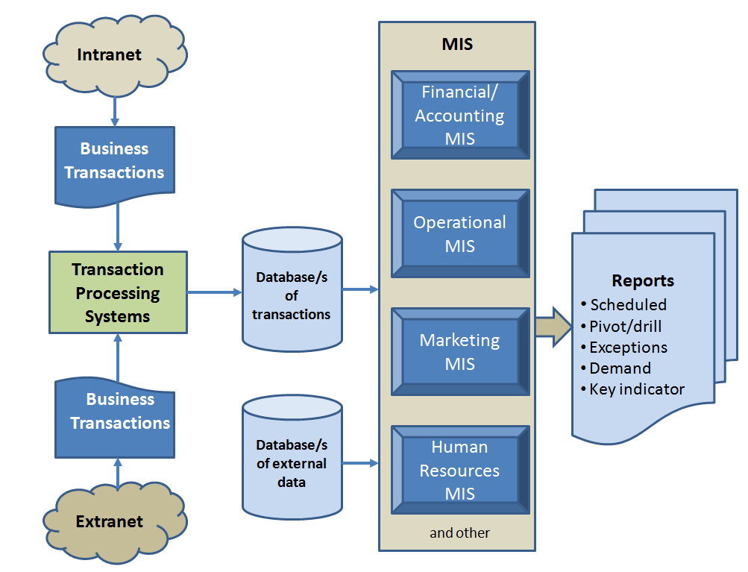

**4**

**3**

**2**

**1**