**ANALYTICAL DECISION-MAKING**

**Learning Outcome 2: ACTIVITY 6**

**BI – Technology in action**

Case study: BI – Technology in action

Microsoft Power BI Oracle Business Analytics

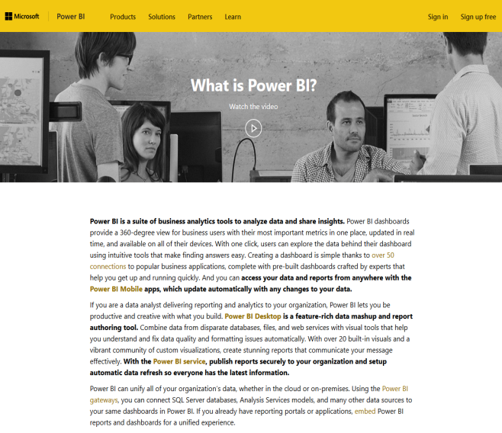 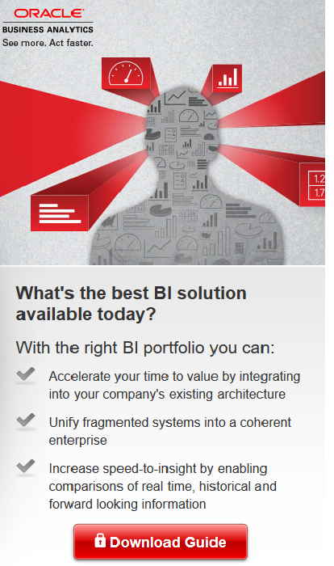

<https://powerbi.microsoft.com/en-us/what-is-power-bi/> <https://go.oracle.com>

Other links to look at:

<https://www.ibm.com/business-intelligence>

<https://www.sap.com/uk/solution/platform-technology/analytics/business-intelligence-bi.html>

<http://www.qlik.com/en-gb> - Qlik let you download trial software for free

1. Review and compare the case study examples for IBM, SAP and Qlik
2. What type of businesses are these companies targeting?
3. What services do each offer?
4. Evaluate each website?
5. Based on this information which would you recommend and why?

*Hint: You might wish to draw up a table comparing the organisations.*