**ANALYTICAL DECISION-MAKING**

**Learning Outcome 4: ACTIVITY 6**

**Delphi Technique**

**Scenario: Fashionista and the fashion industry**

*Work in pairs/small groups:*

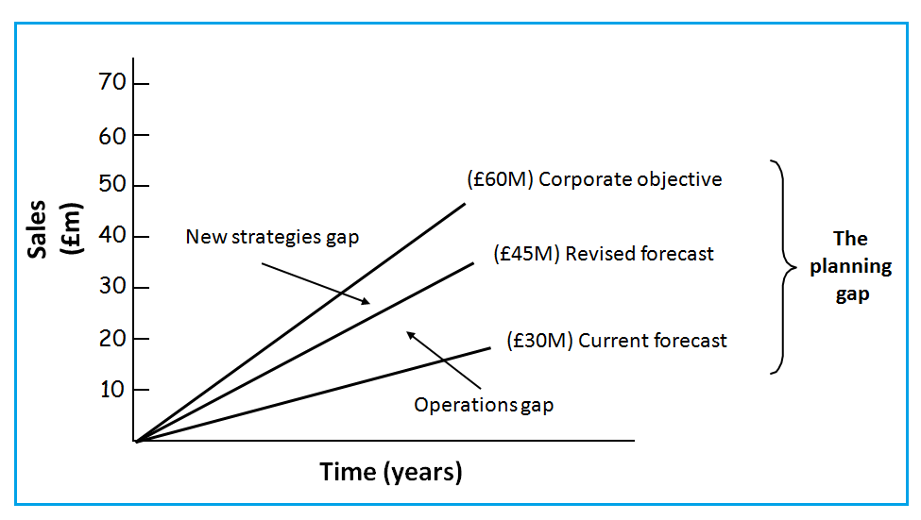

**Stage 1**

1. Review the options you created for Fashionista to meet the planning gaps in the last session.
2. List the advantages of your options; keep a copy.
3. Share your work with the other groups in your class.

**Stage 2**

1. Review all the options – (yours and the other groups); check for similarities/differences and made any adjustments to capture all the key ideas from all the groups.
2. Discuss which option/s to put forward to the next stage.
3. Refine and share your options with the other groups.

**Stage 3**

1. Still in your working group decide on a best option version to submit for class discussion.
2. Share best option selection of each group, discuss.
3. Agree final choice, making any adjustments as necessary to reach consensus.