**BUYER AND CONSUMER BEHAVIOUR**

**Learning Outcome 1: Activity 12**

**INDIVIDUAL ACTIVITY**

## **Do social, psychological and marketing influence consumer choice?**

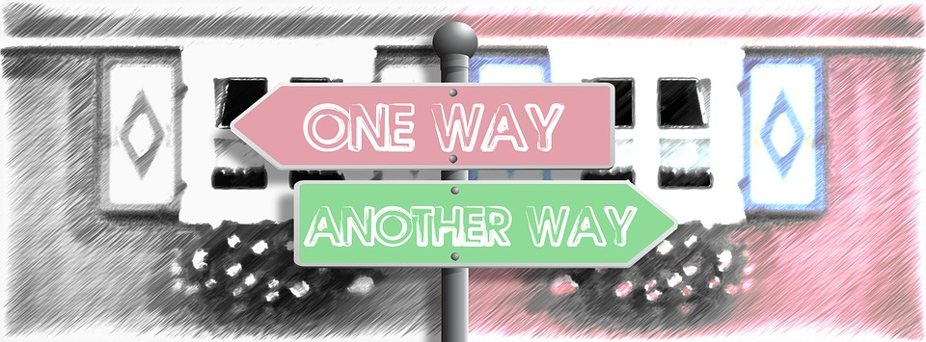The Howard-Sheth model of purchase decision making

Read through the article about consumer behaviour and the theories put forward by Howard Sheth. Come to the next session prepared to discuss the model and with examples for each of the three levels of decision-making.

<http://thinkingaboutmarketing.blogspot.co.uk/2011/07/consumer-behaviour-models-part-ii.html>

What kind of purchase would require extensive problem solving; limited problem solving and routinised response behaviour?

*(Image source:* [*https://pixabay.com/en/one-way-street-decisions-opportunity-1991865/*](https://pixabay.com/en/one-way-street-decisions-opportunity-1991865/)*)*