**BUYER AND CONSUMER BEHAVIOUR**

**Learning Outcome 1: Activity 8**

**GROUP ACTIVITY**

## **Influence of external forces**

The big spending debate

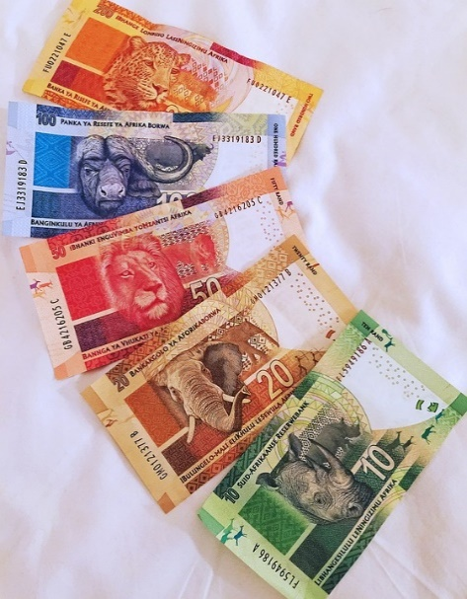Research suggests that consumer spending changes significantly during a recession, but that consumers don’t always cut back on the things that cost them the most. Branded cosmetics, clothing and travel are all purchases that remain relatively stable.

Your challenge

Working in groups of three or four, imagine you are the marketing team for a large national food retailer and your country is facing an economic downturn.

Your senior leadership team has asked you to predict how consumer behaviour might change as recession impacts on their disposable income.

*(Image source: https://pixabay.com/en/african-currency-currency-notes-1219146/)*

* Read through this research report by Booz & Co. to help you identify the areas of spending that are most likely to be affected and explain what the consumer thinking is behind these changing behaviours. For example, consumers might eat out less and spend more on cooking ingredients for dining at home. <https://www.strategyand.pwc.com/media/file/Consumer-Spending-in-the-Economic-Downturn.pdf>
* Make some notes about your findings in preparation for a meeting with the senior leadership team.
* Share and compare your findings with other groups. What did you find? What did they find? And so on.

Here are some predictions to get you started:

* Concern for the planet and environment will be put on hold (only 7.8% of consumers surveyed expect to cut back home use of electricity, heating fuel, and water).
* Consumers will purchase fewer premium clothes.