**BUYER AND CONSUMER BEHAVIOUR**

**Learning Outcome 3: Activity 3**

## **GROUP ACTIVITY**

## **Hot chocolate**

But is there a market for chilli chocolate?

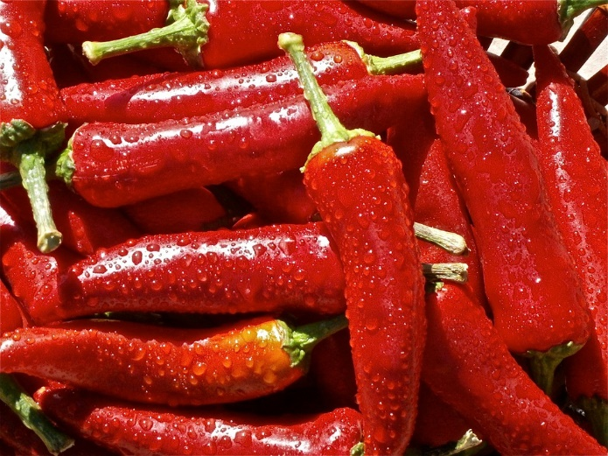Artisan Chocolate Inc. is a small confectionery manufacturer based just outside Nairobi. The business prides itself on producing the best luxury chocolate products in the region and sells them to high-end retailers and online.

The business is ready to launch its newest product, Firefox Chilli Chocolate. It’s a product not for the faint-hearted as each bar contains one Habanero chilli pepper in its ingredients.

Your challenge

* Imagine you are the marketing team for Artisan Chocolate Inc. and you are working hard to understand precisely who the target consumer will be for Firefox Chilli Chocolate and the size of the potential market in Nairobi.
* Your task is to develop a research plan that will help provide the answers.
* Your plan should take the form of an A4 poster that shows the path from information need to data analysis methods. Your idea is to use the poster during a meeting with the Managing Director to secure the research funds needed to execute your plan.

Things to consider

* What is the research question?
* Who is the group of consumers you need to know about?
* What is the role of secondary research?
* What is the role of primary research?
* What consumer insights do you need to gather?
* What data can help you quantify the opportunity?

**Present your poster to others in the class to gain and give feedback.**