**BUYER AND CONSUMER BEHAVIOUR**

**Learning Outcome 3: Activity 4**

## **HOMEWORK ACTIVITY**

## **Google’s consumer barometer**

Helping marketers to understand how people use the internet

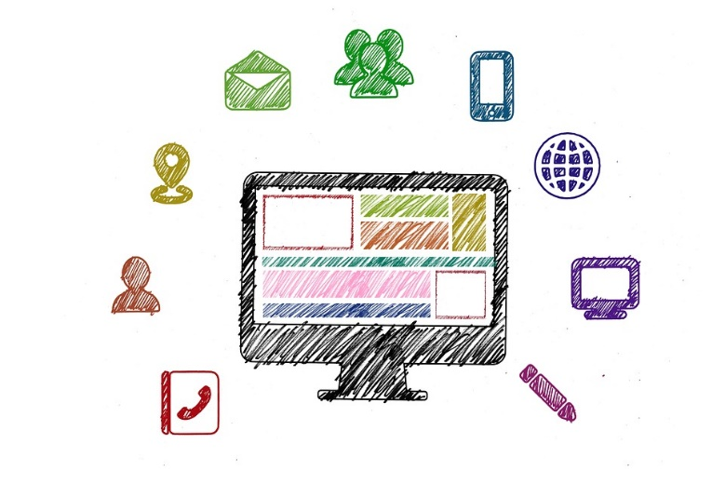

Visit the Think with Google website and explore the research data that you find there.

Be curious about the depth and breadth of information and find five strong insights that interest you the most. These can be about anything or anyone!

Make some notes and come to the next session prepared to discuss your findings.

<https://www.consumerbarometer.com/en/>

*(Image source:* [*https://pixabay.com/en/social-media-digitization-digital-2786261/*](https://pixabay.com/en/social-media-digitization-digital-2786261/)*)*