**BUYER AND CONSUMER BEHAVIOUR**

**Learning Outcome 3: Activity 9**

## **GROUP ACTIVITY**

## **The importance of protecting customer data**

Do you know what the law is in your home country?

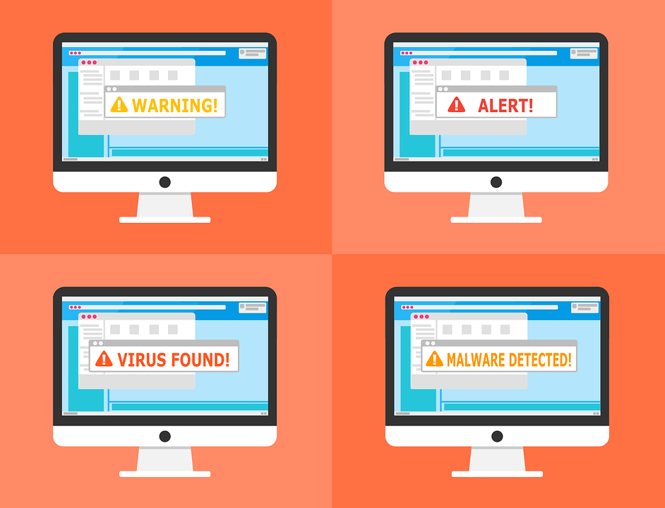Data security is a highly sensitive topic now as cybercrime is on the increase both in terms of frequency and intensity. Brands must be constantly diligent to protect their consumers’ personal information. But they also must be very careful to comply with legislation.

Ignorance of the law is never accepted as a defence in a court.

Your challenge

* Imagine you are the marketing team working for a major national retailer. The business carries out extensive consumer research and gathers vast amounts of data about their spending habits and online behaviours as well as personal data captured as part of on-going email marketing campaigns.
* Your bosses have asked you to work together to research the current legislation regarding data protection and to prepare a report that highlights your key findings.
* They have also asked you to look at general trends in terms of ethics and behaviours and whether brands are changing their attitudes towards gathering, storing and using consumer data.
* Carry out some online research to identify the key data protection legislation that applies in your region and make some brief notes about the key findings. For example, the Protection of Personal Information Act ([POPI Act](https://www.michalsons.com/focus-areas/privacy-and-data-protection/popi-act-protection-of-personal-information/11105)) was recently enacted in South Africa.
* Also research the current thinking about using consumer data in marketing campaigns to understand if there are any important codes of conduct recommended by any industry bodies.

**Come prepared to debrief your bosses with your research findings.**

*(Image* [*source*](https://pixabay.com/en/warning-alert-detected-malware-2168379/)*)*