**BUYER AND CONSUMER BEHAVIOUR**

**Learning Outcome 4: Activity 3**

**PAIRS ACTIVITY**

## **Flying high with the new ‘gesture drone’**

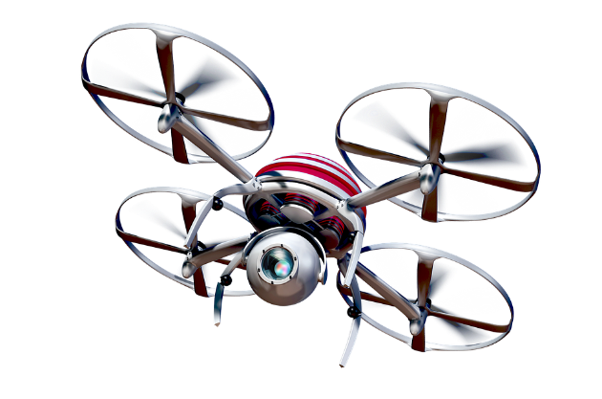

The global market for personal drones has grown quickly to become the latest high-tech business opportunity for entrepreneurs and private investors. So, it’s no surprise to see companies working hard to be the one to develop the next generation of drone.

Buzz Inc. is a small tech business that has created what they believe to be the next breakthrough innovation of drone; a tiny palm-sized machine that’s capable of taking 360° video and streaming it live to any device. It is controlled merely with hand gestures and it has over 10 hours of solar-powered battery life.

You have tested the market and you believe that a US$45 price point will ensure mass sales and acceptable profit margins. You need to raise US$50k quickly to ensure you are first to market so you need to find an investor willing and able to fund the launch.

You have arranged a presentation to a potential investor in the morning where you will present a description of the target consumer segment. Who will your mini-drone appeal to?

Your challenge

* Working in pairs, imagine that you are owners of Buzz Inc. and develop a description of the ideal target consumer segment using the bases of segmentation that you have been exploring in the session.
* Carry out some research online to support your assumptions and provide some strong arguments for why you believe you have identified the right target consumer segment/s.
* Present your consumer segment as an illustration of the ideal consumer and annotate it with your definition, using the checklist below:
* **Demographics**
* **Psychographics**
* **Behavioural**
* **Geographic**
* **Benefits sought**

Share your recommendations with the class to give and get feedback.

*(*[*Image source*](https://pixabay.com/en/quadrocopter-camera-drone-fly-1658967/)*)*