**INTEGRATED MARKETING COMMUNICATIONS**

**LEARNING OUTCOME 2: ACTIVITY 4**

**Pairs Activity**

**Make it personal**

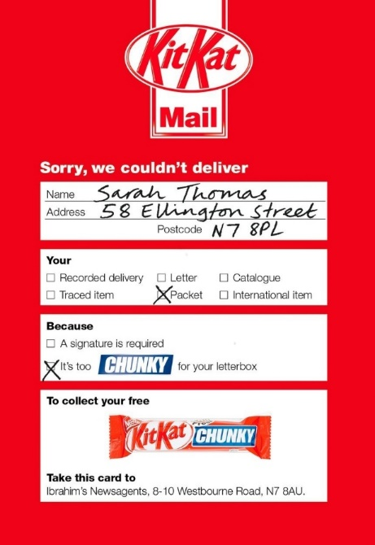

We know that personalisation is a powerful marketing tool and you can see here how chocolate brand KitKat as used it to connect with consumers.

This was a direct mail campaign that was sent to 5,000 consumers and was intended to look like a UK national Post Office notice about an undelivered parcel.

It directed the consumer to their nearest stockist and the reward was a free KitKat Chunky bar.

**Your challenge**

Working in pairs, imagine that you are the Brand Manager for KitKat and that you have planned direct mail into the DM campaign.

**Write the agency brief for this mailer, making reasonable assumptions about:**

* The target consumer segment
* The target retail channel
* The campaign objectives (quantitative and qualitative)
* The key performance indicators
* The consumer response (brand positioning; attitudes; opinions, etc).

**Share your agency brief with other teams to give and receive feedback.**