**INTEGRATED MARKETING COMMUNICATIONS**

**LEARNING OUTCOME 3: ACTIVITY 4**

**Groups Activity**

**Being seen in all the right places**

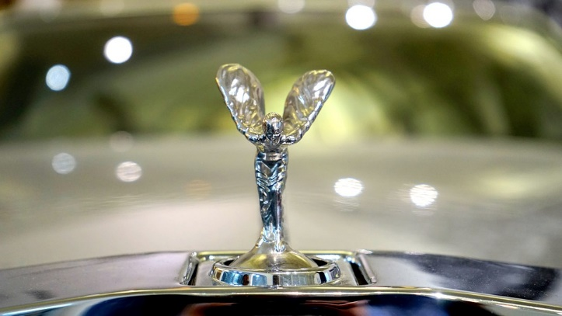After years of speculation, Rolls Royce have decided to expand their target market with the introduction of a new model aimed not at the super-rich but at the next ‘level’ down.

This car will be competing with the top of the range offers from brands like Mercedes, BMW, Lexus and Lincoln.

The typical customer is likely to be main board directors of very large companies, offering a level of luxury and prestige above that of the competition.

Your task is to describe how you might use online and/or offline channels to position the new car in the desired market but without damaging the iconic reputation of the Rolls Royce marque in its traditional markets.

**Your challenge**

* In small groups come up with a theme for this challenge (e.g. a headline that would run through all media – but don’t spend time producing the ad content) and how you would choose the media channels that would meet the objectives.

Produce a presentation of not more than 6 slides introducing your theme, the media channels identified and the rationale behind it.