**OPERATIONS MANAGEMENT**

**Learning Outcome 2: ACTIVITY 2**

## **Supply chain risks: examples of type and origin**

Refer to slide 25 in the tutor presentation ‘Supply chain risks: type and origin’, shown below:

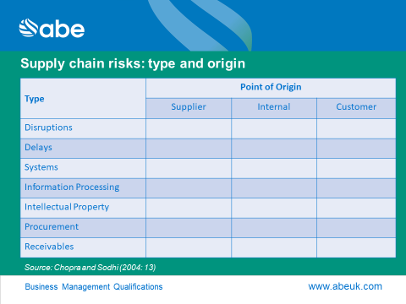

Give at least one example for each combination of type and origin of risk in context of a supplier of medicines to the hospitals.