**OPERATIONS MANAGEMENT**

**Learning Outcome 3: ACTIVITY 3**

## **Sources of supply: who can supply**

Refer to the slide in your tutor’s presentation ‘Who can supply’, under ‘Source of supply’ shown below:

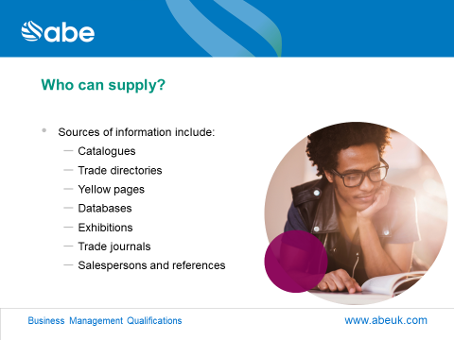

1. Discuss advantages of each source of information on potential suppliers.
2. You have been appointed as the Purchasing Manager in a large hospital in your country. Your first task is to find suppliers for a suitable MRI scanner. The budget for the scanner is $1.5 million. What two sources of information will you use? And why?