**ADVANCED PROJECT MANAGEMENT**

**LEARNING OUTCOME 4: ACTIVITY 8**

**HOMEWORK**

## **Need vs. purpose**

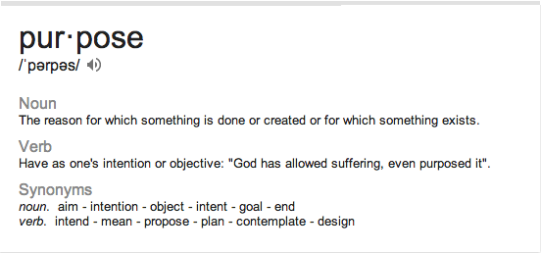

Draw a poster showing a visual representation of need vs. purpose.