**BUSINESS STRATEGY AND DECISION-MAKING**

**Learning outcome 3: Activity 12**

**Scenario development**

**In working groups (approximately 6-8)**

**Part one – Balanced Score Card**

TASK

Using the Apple case, develop a balanced scorecard (see your study guide) to answer the four perspective questions.

*Give feedback.*

**Part two – Delphi technique**

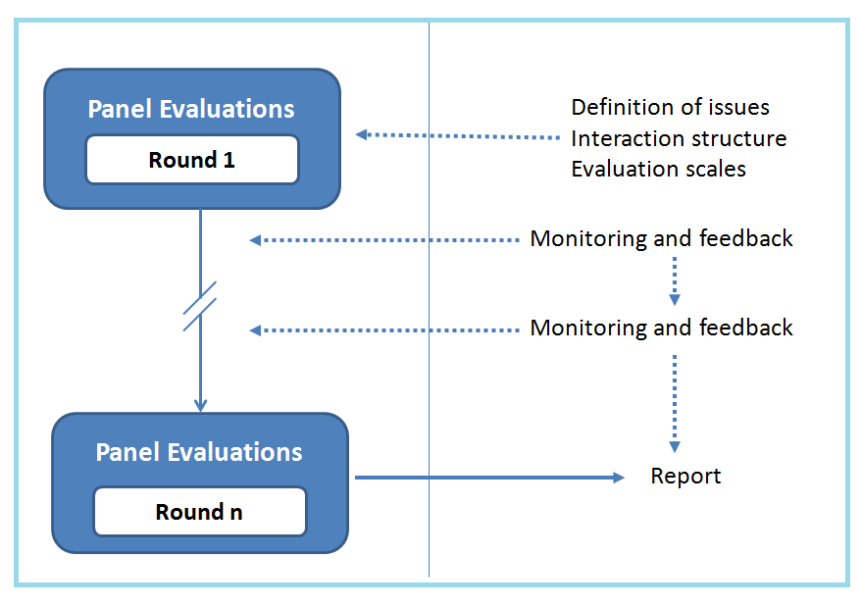

TASK

Use the Toyota case material. Working in pairs (within original groups of 6-8) use the Delphi technique (2-3 rounds). Develop a consensus and give feedback.