**BUSINESS STRATEGY AND DECISION-MAKING**

**Learning outcome 4: Activity 1**

**Stakeholder power and interest matrix**

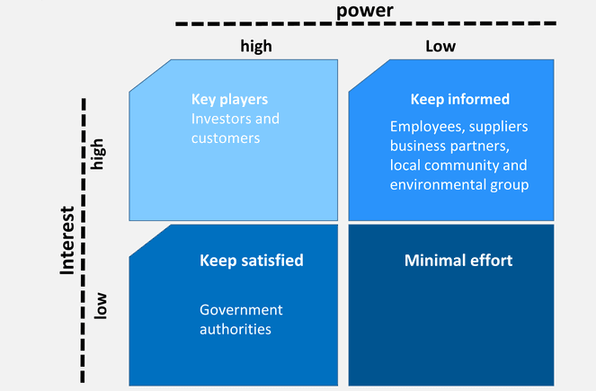

**Scenario: Grande Construction Company (1)**

Planners responsible for management strategy in Grande Construction Company completed a stakeholder influence matrix sometime ago (see above). They have recently acquired a derelict machine repair unit with agricultural land and submitted plans for a large new private housing development (200 new homes) in a semi-rural village location. This has been rejected by the local planning authorities who have requested they put forward plans for financial and other support for the following if they are to be successful on resubmission:

* New government building regulations addressing environmental concerns and use of industrial buildings.
* Potential difficulties with change of use from agricultural/industrial buildings.
* Local laws concerning provision of community housing in agricultural/rural areas.
* Provision of road infrastructure and community amenities (e.g. schools, retail and services such as local healthcare centres).

The company realises that these factors will have an impact on costs of the development and its profits.

TASKS

1. What is the likely impact of this rejection on the existing stakeholder interests?
2. Redraw the power/influence matrix to reflect the positions of new and existing stakeholders.
3. Suggest strategies/options for resolving this problem.