**BUSINESS STRATEGY AND DECISION-MAKING**

**Learning outcome 4: Activity 6**

**Homework – SAFe concepts**

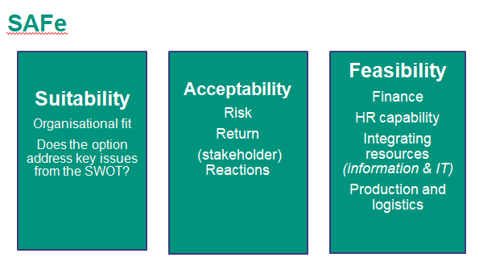

**Work in pairs**

TASK

1. Establish success criteria using SAFe concepts for Apple Corporation in the future

*Be prepared to discuss at the next session.*