**DEVELOPING INTERNATIONAL MARKETS**

**LEARNING OUTCOME 2: ACTIVITY 4**

**Group Activity**

## **Risk management**

In small groups, complete a risk management plan – referring to the example below as a guide for style and content.

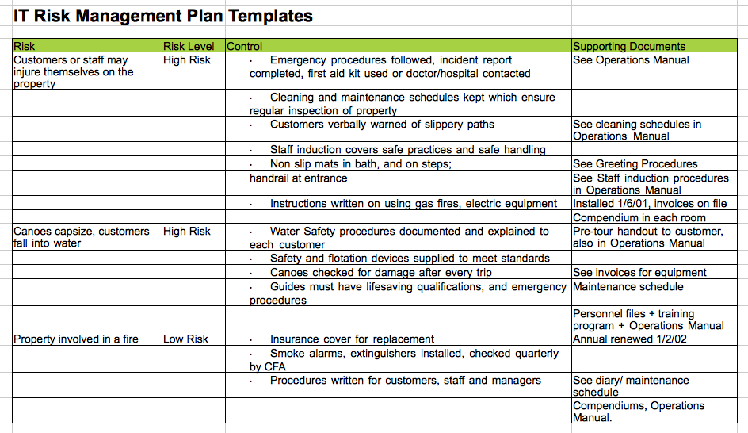

* Select a company and identify the potential risks that they may face.
* Specify the likely severity of the risks.
* Identify ways to address the risks.