**ORGANISATIONAL DESIGN AND DEVELOPMENT**

**Learning Outcome 2: ACTIVITY 5**

**Group Activity**

**Layers of culture**

As a group apply the four layers of culture to your chosen organisation.

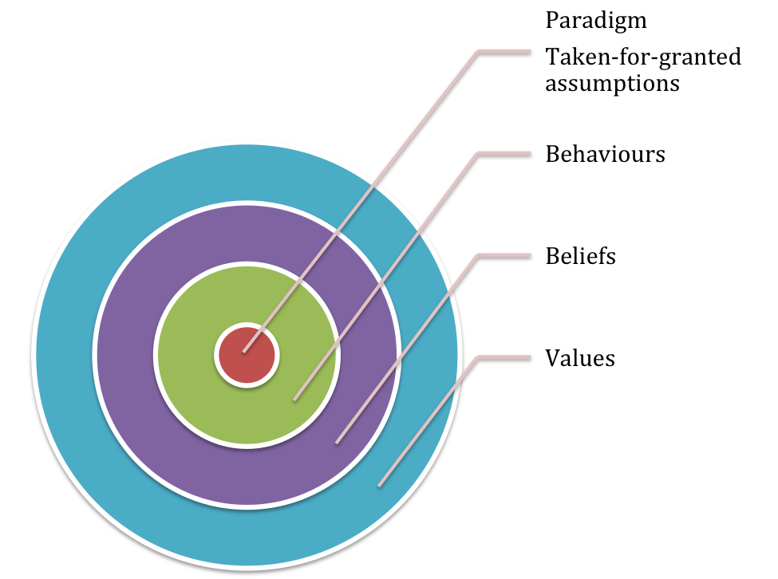

Reflect on the layers of culture. Which do you think have most impact on organisations in your country?